## Testing of Business Card Price Set Up Using OnPrintShop with Copy Express Prices

**Prices set up by Chesda Reth, 10 Oct 2013**

**Pricing tested by Helen James, 10 Oct 2013**

<http://salesdemo.onprintshop.com/en/awesome-cards/>

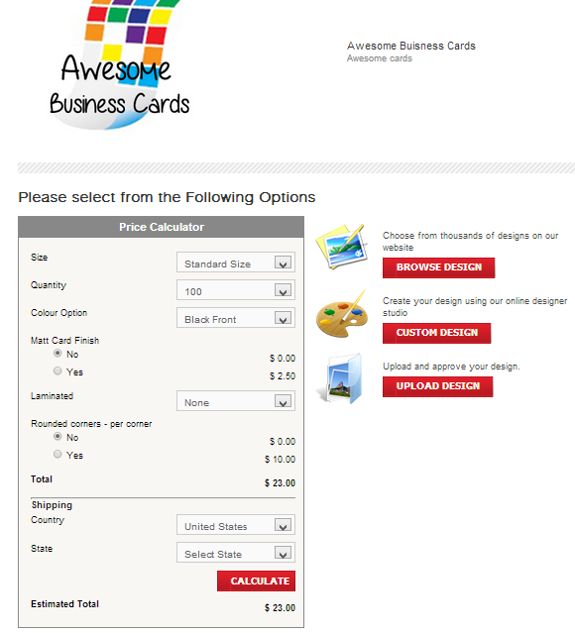

### Test Plan

A comparison of the result displayed on the OnPrintShop public demo site (as set up by Chesda o the OnPrintShop Admin demo site) to that which is expected from the Copy Express Spread Sheet.

To test each option for 100, 200, 250, 500, 1000 and 2000 cards where practical and for 250, 500 and 1000 for folding costs. Test the Boundaries and mid-range with all options turned off and all turned on.

### Test Cases with Results

**Test Case 1**: Standard Size Black Front, No Matt Finish, Not laminated, No Rounded Corners, No Shipping

|  |  |  |  |
| --- | --- | --- | --- |
| Test # | Quantity Ordered | Result Displayed | Expected Result |
| 1.1 | 100 | $23.00 | $23.00 |
| 1.2 | 200 | $32.00 | $32.00 |
| 1.3 | 250 | $38.00* | $38.00 |
| 1.4 | 500 | $49.00* | $49.00 |
| 1.5 | 1000 | $67.00* | $67.00 |
| 1.6 | 2000 | $112.00** | $112.00 |

* Showed options for folded cards.

**No folding options over 1000 Cards ordered

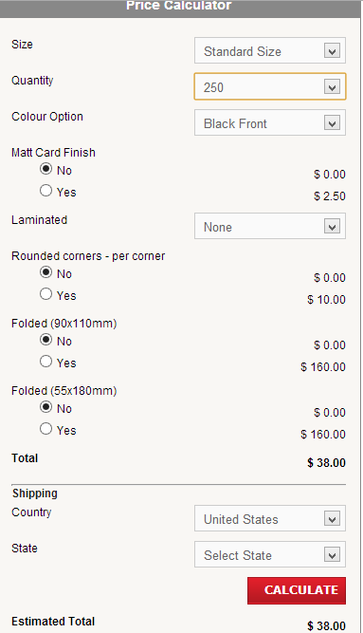

Test Result: **PASS**

**Test Case 2**: Standard Size Black Front and Back, No Matt Finish, Not laminated, No Rounded Corners, No Shipping

|  |  |  |  |
| --- | --- | --- | --- |
| Test # | Quantity Ordered | Result Displayed | Expected Result |
| 2.1 | 100 | $32.00 | $32.00 |
| 2.2 | 200 | $40.00 | $40.00 |
| 2.3 | 250 | $46.00* | $46.00 |
| 2.4 | 500 | $67.00* | $67.00 |
| 2.5 | 1000 | $98.00* | $98.00 |
| 2.6 | 2000 | $156.00** | $156.00 |

* Showed options for folded cards.

**No folding options over 1000 Cards ordered  
Test Result: **PASS**

**Test Case 3**: Standard Size, Full Colour Front, No Matt Finish, Not laminated, No Rounded Corners, No Shipping

|  |  |  |  |
| --- | --- | --- | --- |
| Test # | Quantity Ordered | Result Displayed | Expected Result |
| 3.1 | 100 | $36.00 | $36.00 |
| 3.2 | 200 | $49.00 | $49.00 |
| 3.3 | 250 | $55.00* | $55.00 |
| 3.4 | 500 | $67.00* | $67.00 |
| 3.5 | 1000 | $98.00* | $98.00 |
| 3.6 | 2000 | $156.00** | $156.00 |

* Showed options for folded cards.

**No folding options over 1000 Cards ordered  
Test Result: **PASS**

**Test Case 4**: Standard Size, Full Colour Front and Back, No Matt Finish, Not laminated, No Rounded Corners, No Shipping

|  |  |  |  |
| --- | --- | --- | --- |
| Test # | Quantity Ordered | Result Displayed | Expected Result |
| 4.1 | 100 | $54.00 | $54.00 |
| 4.2 | 200 | $72.00 | $72.00 |
| 4.3 | 250 | $80.00* | $80.00 |
| 4.4 | 500 | $107.00* | $107.00 |
| 4.5 | 1000 | $134.00* | $134.00 |
| 4.6 | 2000 | $187.00** | $187.00 |

* Showed options for folded cards.

**No folding options over 1000 Cards ordered  
Test Result: **PASS**

**Test Case 5**: Standard Size, Full Colour Front and Black Back, No Matt Finish, Not laminated, No Rounded Corners, No Shipping

|  |  |  |  |
| --- | --- | --- | --- |
| Test # | Quantity Ordered | Result Displayed | Expected Result |
| 5.1 | 100 | $45.00 | $45.00 |
| 5.2 | 200 | $58.00 | $58.00 |
| 5.3 | 250 | $65.00* | $65.00 |
| 5.4 | 500 | $85.00* | $85.00 |
| 5.5 | 1000 | $129.00* | $129.00 |
| 5.6 | 2000 | $200.00** | $200.00 |

* Showed options for folded cards.

**No folding options over 1000 Cards ordered  
Test Result: **PASS**

**Test Case 6**: Standard Size Black Back, Matt Finish, Not laminated, No Rounded Corners, No Shipping

|  |  |  |  |  |
| --- | --- | --- | --- | --- |
| Test # | Quantity Ordered | Displayed Surcharge | Result Displayed | Expected Result |
| 6.1 | 100 | $2.50 | $25.50 | $25.50 |
| 6.2 | 200 | $2.50 | $34.50 | $34.50 |
| 6.3 | 250 | $2.50 | $40.50* | $40.50 |
| 6.4 | 500 | $5.00 | $54.00* | $54.00 |
| 6.5 | 1000 | $10.00 | $77.00* | $77.00 |
| 6.6 | 2000 | $20.00 | $132.00** | $132.00 |

* Showed options for folded cards.

**No folding options over 1000 Cards ordered  
Test Result: **PASS**

**Test Case 7**: Standard Size Black Back, No Matt Finish but laminated front only (Offset Film), No Rounded Corners, No Shipping

|  |  |  |  |
| --- | --- | --- | --- |
| Test # | Quantity Ordered | Result Displayed | Expected Result |
| 7.1 | 100 | $53.00 | $53.00 |
| 7.2 | 200 | $62.00 | $62.00 |
| 7.3 | 250 | $68.00* | $68.00 |
| 7.4 | 500 | $79.00* | $79.00 |
| 7.5 | 1000 | $97.00* | $97.00 |
| 7.6 | 2000 | $142.00** | $142.00 |

* Showed options for folded cards.

**No folding options over 1000 Cards ordered  
Test Result: **PASS**

**Test Case 8**: Standard Size Black Back, No Matt Finish but laminated both sides (offset Film), No Rounded Corners, No Shipping

|  |  |  |  |
| --- | --- | --- | --- |
| Test # | Quantity Ordered | Result Displayed | Expected Result |
| 8.1 | 100 | $53.00 | $53.00 |
| 8.2 | 200 | $62.00 | $62.00 |
| 8.3 | 250 | $68.00* | $68.00 |
| 8.4 | 500 | $79.00* | $79.00 |
| 8.5 | 1000 | $97.00* | $97.00 |
| 8.6 | 2000 | $157.00** | $157.00 |

* Showed options for folded cards.

**No folding options over 1000 Cards ordered  
Test Result: **PASS**

**Test Case 9**: Standard Size Black Back, No Matt Finish Not laminated, Rounded Corners, No Shipping

|  |  |  |  |  |
| --- | --- | --- | --- | --- |
| Test # | Quantity Ordered | Displayed Surcharge | Result Displayed | Expected Result |
| 9.1 | 100 | $10.00 | $33.00 | $33.00 |
| 9.2 | 200 | $10.00 | $42.00 | $42.00 |
| 9.3 | 250 | $10.00 | $48.00* | $48.00 |
| 9.4 | 500 | $20.00 | $69.00* | $69.00 |
| 9.5 | 1000 | $40.00 | $107.00* | $107.00 |
| 9.6 | 2000 | $80.00 | $192.00** | $192.00 |

* Showed options for folded cards.

**No folding options over 1000 Cards ordered  
Test Result: **PASS**

**Test Case 10**: Standard Size Black Back, No Matt Finish Not laminated, No Rounded Corners, No Shipping. Folded (90 x 110)

|  |  |  |  |  |
| --- | --- | --- | --- | --- |
| Test # | Quantity Ordered | Displayed Surcharge | Result Displayed | Expected Result |
| 10.1 | 250 | $160.00 | $198.00 | $198.00 |
| 10.2 | 500 | $199.00 | $248.00 | $248.00 |
| 10.3 | 1000 | $250.00 | $317.00 | $317.00 |

Test Result: **PASS**

**Test Case 11**: Standard Size Black Back, No Matt Finish Not laminated, No Rounded Corners, No Shipping. Folded (55 x 180)

|  |  |  |  |  |
| --- | --- | --- | --- | --- |
| Test # | Quantity Ordered | Displayed Surcharge | Result Displayed | Expected Result |
| 11.1 | 250 | $160.00 | $198.00 | $198.00 |
| 11.2 | 500 | $199.00 | $248.00 | $248.00 |
| 11.3 | 1000 | $250.00 | $317.00 | $317.00 |

Test Result: **PASS**

**NB:** Both folded options could be selected, applying double the surcharge (1000 cards -$567). Not very practical.

**Test Case 12**: Standard Size, Full Colour Front, No Matt Finish Not laminated, No Rounded Corners, No Shipping. Folded (55 x 180)

|  |  |  |  |  |
| --- | --- | --- | --- | --- |
| Test # | Quantity Ordered | Displayed Surcharge | Result Displayed | Expected Result |
| 12.1 | 250 | $160.00 | $215.00 | $215.00 |
| 12.2 | 500 | $199.00 | $266.00 | $266.00 |
| 12.3 | 1000 | $250.00 | $348.00 | $348.00 |

Test Result: **PASS**

**Test Case 13**: Standard Size, Full Colour Front, Matt Finish, Not laminated, No Rounded Corners, No Shipping. Folded (55 x 180)

|  |  |  |  |  |
| --- | --- | --- | --- | --- |
| Test # | Quantity Ordered | Displayed Surcharge | Result Displayed | Expected Result |
| 13.1 | 250 | $160.00 + $2.50 | $217.50 | $217.50 |
| 13.2 | 500 | $199.00 + $5.00 | $271.00 | $271.00 |
| 13.3 | 1000 | $250.00+ $10.00 | $358.00 | $358.00 |

Test Result: **PASS**

**Test Case 14**: Standard Size, Full Colour Front, Matt Finish, Not laminated, Rounded Corners, No Shipping. Folded (55 x 180)

|  |  |  |  |  |
| --- | --- | --- | --- | --- |
| Test # | Quantity Ordered | Displayed Surcharge | Result Displayed | Expected Result |
| 14.1 | 250 | $160.00 + $2.50 + $10.00 | $227.50 | $227.50 |
| 14.2 | 500 | $199.00 + $5.00 + $20.00 | $291.00 | $291.00 |
| 14.3 | 1000 | $250.00+ $10.00 +40.00 | $398.00 | $398.00 |

Test Result: **PASS**

***NB The price matrix only allows for the addition of one rounded corner, there is no place to say how many you want.***

### Boundary Testing

**Test Case 15**: Smallest Cheapest Order with no optional extras.

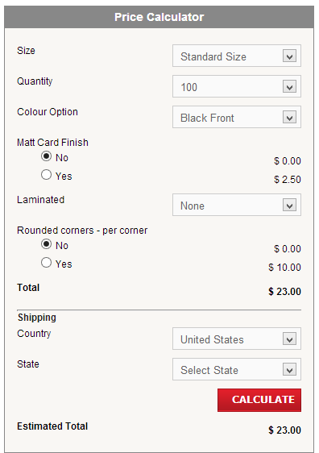Result displayed = $23.00, Expected Result = $23.00, Test Result: **PASS**

**Test Case 16**: Smallest Cheapest Order with all possible optional extras.

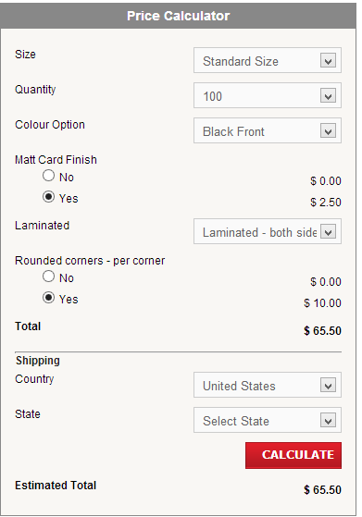Result Displayed = $65.50, Expected result = $65.50   
Test Result: **PASS**

**Test Case 17**: Largest tested order with the dearest print option (full colour) and no possible optional extras. 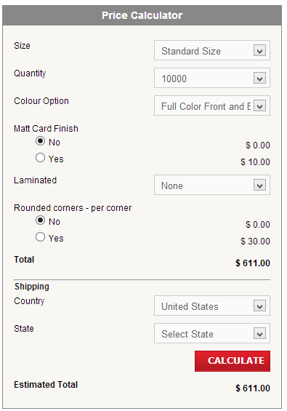 Result Displayed = $611.00, Expected result = $611.00  
Test Result: **PASS**

**Test Case 18**: Largest dearest order with all possible optional extras.

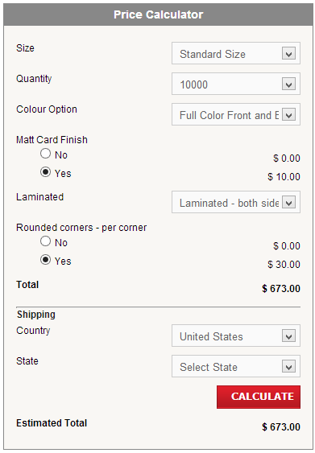 Result Displayed = $673.00, Expected result =$673 Test Result: **PASS**

### Mid-Range Testing

**Test Case 19**: 1000 Black Cards with no optional extras

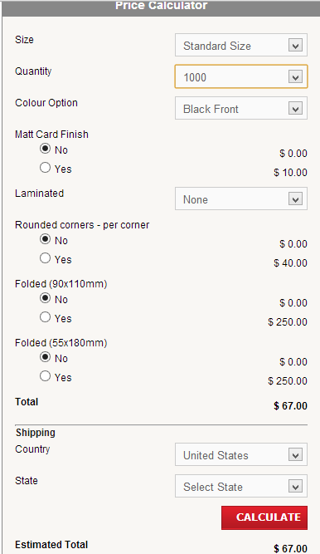Result Displayed = $67.00 Expected Result = $67.00, Test Result: **PASS**

**Test Case 20**: 1000 Black Cards with all optional extras (only one fold included)

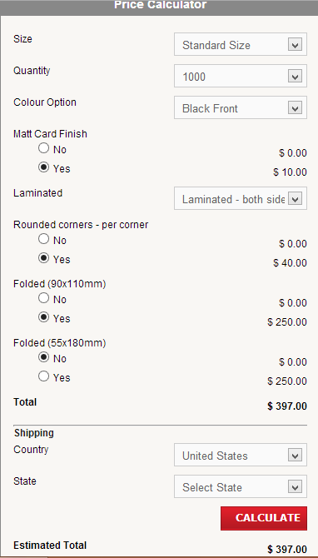 Result Displayed = $397.00, Expected Result=$397.00 Test Result: **PASS**

### Result Summary

All tests and test cases Passed (i.e. the price displayed was correct for the options selected)

Two set up faults found:

1. The Rounded corners only allows for one corner to be selected, no option to add more or to indicate how many are required.
2. The radio buttons allow for both types of folding to be selected, this seems impractical for a business card.

### Responses to faults found -11 October 2013

Chesda changed it to Radio Boxes with 4 corner options and selecting 1, 2 or 3 corners will make a dropdown box appear and users can select which sides they want the corners to be. If they click the Question Mark icon beside it a popup will show the sides they can choose from.

He also fixed the Folded Options so you can only tick Yes on one of the options, but it’s not perfect because if you tick Yes for Folded (55x180mm), then the other option will still be there but you won’t be able to tick both at the same time.

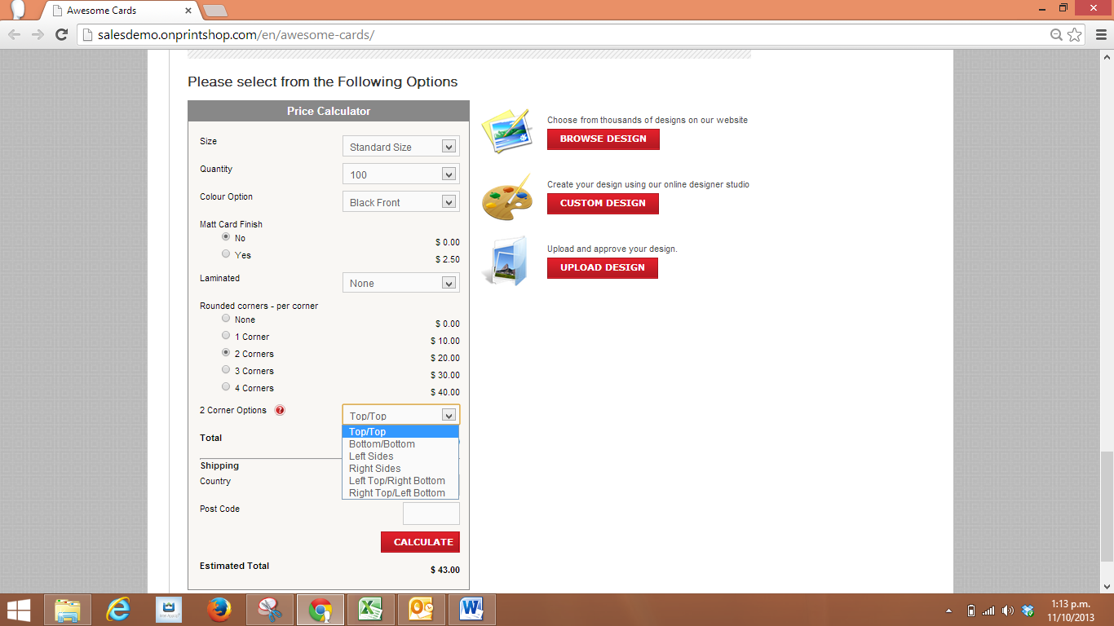 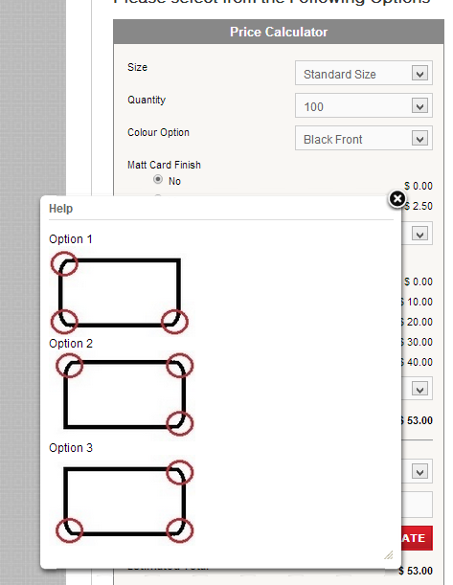

### Retest Test Plan

1. First regression tests using the Boundary and Mid-Range tests to ensure the changes have not created any pricing areas.
2. Run a set of new tests to cover all of the Corner Pricing options.
3. Rerun test cases 10 11, 12 and 13 to test the folding option pricing

### Test Cases with Results

### Boundary Testing-Regression Test

**Test Case 15R**: Smallest Cheapest Order with no optional extras.

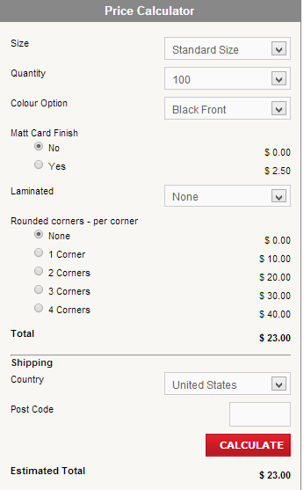Result displayed = $23.00, Expected Result = $23.00, Test Result: **PASS**

**Test Case 16R**: Smallest Cheapest Order with all possible optional extras.

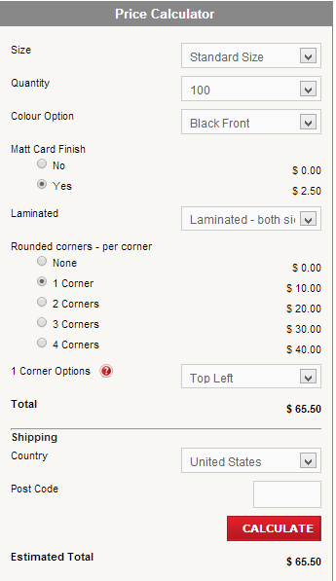 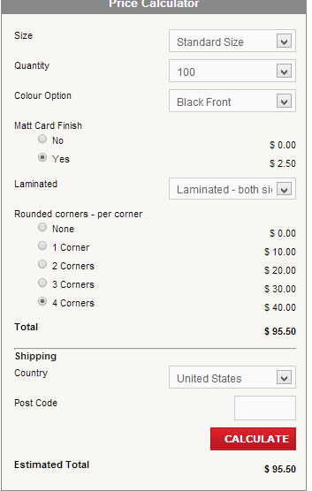  
Result Displayed (for one Corner as previously tested) = $65.50, Expected result = $65.50 Test Result: **PASS**Result Displayed (for four Corners not tested) = $95.50, Expected result = $95.50 Test Result: **PASS**

**Test Case 17R**: Largest tested order with the dearest print option (full colour) and no possible optional extras.

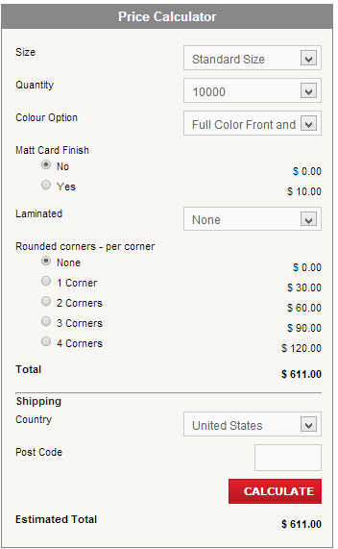 Result Displayed = $611.00, Expected result = $611.00 Test Result: **PASS**

**Test Case 18R**: Largest dearest order with all possible optional extras.

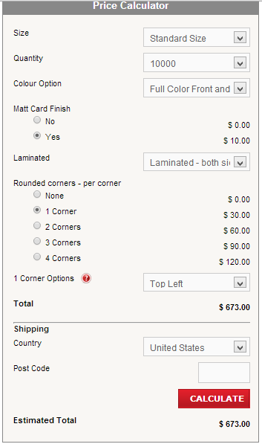 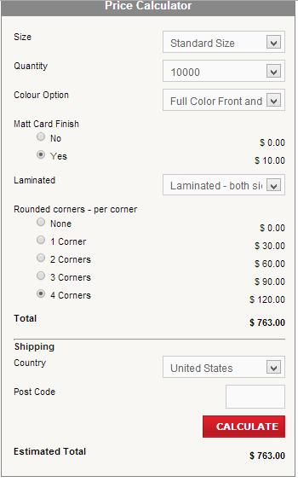  
Result Displayed (With one rounded corner as previously tested) = $673.00, Expected result =$673 Test Result: **PASS**Result Displayed (With 4 rounded corners not previously tested)= $763.00, Expected result =$7633 Test Result: **PASS**

### Mid-Range Testing – Regression Testing

**Test Case 19R**: 1000 Black Cards with no optional extras

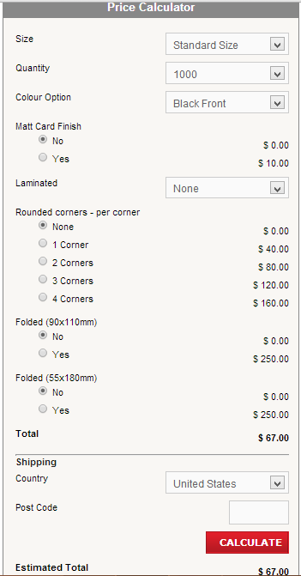Result Displayed = $67.00 Expected Result = $67.00, Test Result: **PASS**

**Test Case 20R**: 1000 Black Cards with all optional extras (only one fold included)

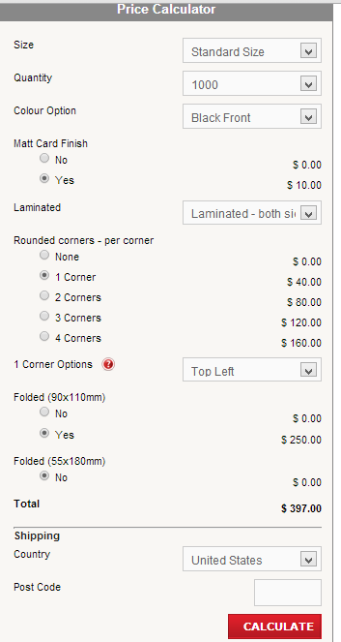 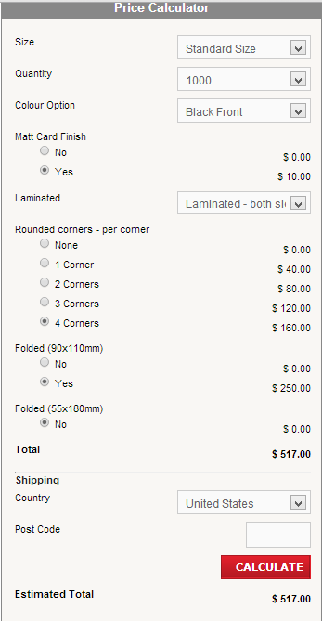  
Result Displayed (for 1 rounded corner as previously tested) = $397.00, Expected Result=$397.00 Test Result: **PASS**Result Displayed (for 4 rounded corners not previously tested) = $517.00, Expected Result=$517.00 Test Result: **PASS**

**Test Case 21**: Standard Size Black Back, No Matt Finish Not laminated, 1Rounded Corner, No Shipping

|  |  |  |  |  |
| --- | --- | --- | --- | --- |
| Test # | Quantity Ordered | Displayed Surcharge | Result Displayed | Expected Result |
| 21.1 | 100 | $10.00 | $33.00 | $33.00 |
| 21.2 | 200 | $10.00 | $42.00 | $42.00 |
| 21.3 | 250 | $10.00 | $48.00* | $48.00 |
| 21.4 | 500 | $20.00 | $69.00* | $69.00 |
| 21.5 | 1000 | $40.00 | $107.00* | $107.00 |
| 21.6 | 2000 | $80.00 | $192.00** | $192.00 |

* Showed options for folded cards. **No folding options over 1000 Cards ordered  
NB All tests were double checked with all four corner positions (Top Left, Top Right, Bottom Left, Bottom Right)  
Test Result: **PASS**

**Test Case 22**: Standard Size Black Back, No Matt Finish Not laminated, 2 Rounded Corners, No Shipping

|  |  |  |  |  |
| --- | --- | --- | --- | --- |
| Test # | Quantity Ordered | Displayed Surcharge | Result Displayed | Expected Result |
| 22.1 | 100 | $20.00 | $43.00 | $43.00 |
| 22.2 | 200 | $20.00 | $52.00 | $52.00 |
| 22.3 | 250 | $20.00 | $58.00* | $58.00 |
| 22.4 | 500 | $40.00 | $89.00* | $89.00 |
| 22.5 | 1000 | $80.00 | $147.00* | $147.00 |
| 22.6 | 2000 | $160.00 | $272.00** | $272.00 |

* Showed options for folded cards. **No folding options over 1000 Cards ordered  
NB All tests were double checked with all six corner positions (Top/Top, Bottom/Bottom, Left Sides, Right Sides , Right Top/ Left Bottom, Left Top/ Right Bottom)  
Test Result: **PASS**

**Test Case 23**: Standard Size Black Back, No Matt Finish Not laminated, 3 Rounded Corners, No Shipping

|  |  |  |  |  |
| --- | --- | --- | --- | --- |
| Test # | Quantity Ordered | Displayed Surcharge | Result Displayed | Expected Result |
| 23.1 | 100 | $30.00 | $53.00 | $53.00 |
| 23.2 | 200 | $30.00 | $62.00 | $62.00 |
| 23.3 | 250 | $30.00 | $68.00* | $68.00 |
| 23.4 | 500 | $60.00 | $109.00* | $109.00 |
| 23.5 | 1000 | $120.00 | $187.00* | $187.00 |
| 23.6 | 2000 | $240.00 | $352.00** | $352.00 |

* Showed options for folded cards. **No folding options over 1000 Cards ordered  
NB All tests were double checked with all three corner positions   
Test Result: **PASS**

**Test Case 24**: Standard Size Black Back, No Matt Finish Not laminated, 4 Rounded Corners, No Shipping

|  |  |  |  |  |
| --- | --- | --- | --- | --- |
| Test # | Quantity Ordered | Displayed Surcharge | Result Displayed | Expected Result |
| 24.1 | 100 | $40.00 | $63.00 | $63.00 |
| 24.2 | 200 | $40.00 | $62.00 | $62.00 |
| 24.3 | 250 | $40.00 | $78.00* | $78.00 |
| 24.4 | 500 | $80.00 | $129.00* | $129.00 |
| 24.5 | 1000 | $160.00 | $227.00* | $227.00 |
| 24.6 | 2000 | $320.00 | $432.00** | $432.00 |

* Showed options for folded cards. **No folding options over 1000 Cards ordered  
Test Result: **PASS**

## Folding Regression Tests

**Test Case 10R**: Standard Size Black Back, No Matt Finish Not laminated, No Rounded Corners, No Shipping. Folded (90 x 110)

|  |  |  |  |  |
| --- | --- | --- | --- | --- |
| Test # | Quantity Ordered | Displayed Surcharge | Result Displayed | Expected Result |
| 10.1 | 250 | $160.00 | $198.00 | $198.00 |
| 10.2 | 500 | $199.00 | $248.00 | $248.00 |
| 10.3 | 1000 | $250.00 | $317.00 | $317.00 |

Test Result: **PASS**

**Test Case 11R**: Standard Size Black Back, No Matt Finish Not laminated, No Rounded Corners, No Shipping. Folded (55 x 180)

|  |  |  |  |  |
| --- | --- | --- | --- | --- |
| Test # | Quantity Ordered | Displayed Surcharge | Result Displayed | Expected Result |
| 11.1 | 250 | $160.00 | $198.00 | $198.00 |
| 11.2 | 500 | $199.00 | $248.00 | $248.00 |
| 11.3 | 1000 | $250.00 | $317.00 | $317.00 |

Test Result: **PASS**

**Test Case 12R**: Standard Size, Full Colour Front, No Matt Finish Not laminated, No Rounded Corners, No Shipping. Folded (55 x 180)

|  |  |  |  |  |
| --- | --- | --- | --- | --- |
| Test # | Quantity Ordered | Displayed Surcharge | Result Displayed | Expected Result |
| 12.1 | 250 | $160.00 | $215.00 | $215.00 |
| 12.2 | 500 | $199.00 | $266.00 | $266.00 |
| 12.3 | 1000 | $250.00 | $348.00 | $348.00 |

Test Result: **PASS**

**Test Case 13R**: Standard Size, Full Colour Front, Matt Finish, Not laminated, No Rounded Corners, No Shipping. Folded (55 x 180)

|  |  |  |  |  |
| --- | --- | --- | --- | --- |
| Test # | Quantity Ordered | Displayed Surcharge | Result Displayed | Expected Result |
| 13.1 | 250 | $160.00 + $2.50 | $217.50 | $217.50 |
| 13.2 | 500 | $199.00 + $5.00 | $271.00 | $271.00 |
| 13.3 | 1000 | $250.00+ $10.00 | $358.00 | $358.00 |

Test Result: **PASS**

## Retest Test Summary

All regression and new tests passed.

Faults Found: As noted earlier by Chesda the radio buttons are not perfect, When the first “yes”option is selected the second “yes” becomes invisible, preventing both from being selected, to change to the second option the first option must be changed to the “no” option first. The same rule does not apply to the second fold radio buttons.

